**HOMEWORK 1**

**What you need to submit in your assignment document (MS Word or PDF):**

**For every question submit:**

**1. SQL query**

**2. SCREENSHOT OF THE OUTPUT (wrong screenshots or missing screenshots will result in deduction of 50% of the points)**

**3. if the number of rows in result set exceeds 15, limit your results to the first 15 rows only**

1. (20 pts) Write a select statement that return 6 columns from invoices table named, vendor id, invoice number, due date, invoice total, %15, and Plus %15. These columns should contain the following details:
   1. Vendor ID: vendor_id
   2. Invoice Number: invoice_number
   3. Due Date: Invoice_due_date
   4. 15%: 15% percent of the invoice_total
   5. Plus 15%: invoice_total + the 15% of invoice_total

Ex. If invoice_total is 1000 then the 15% should be (1000*0.15)=150

“select vendor_id, invoice_number, invoice_due_date,

(invoices.invoice_total * .15) as fifteen,

(invoices.invoice_total + (invoice_total * .15)) as plus

from invoices where rownum <= 15;”

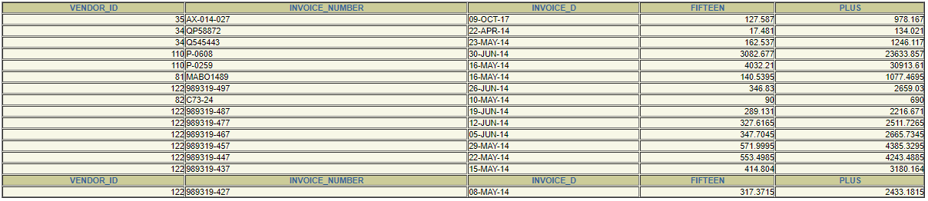

1. (20pts) Filter the results of the previous question to only show those records with an invoice_total that’s greater than or equal to 500 and less than or equal to 1000. Then, sort the result set in descending order by invoice_due_date.

“select vendor_id, invoice_number, invoice_due_date,

(invoice_total * .15) as fifteen,

(invoice_total + (invoice_total * .15)) as plus

from invoices

where invoice_total <= 1000 and invoice_total >= 500

order by invoice_due_date;”

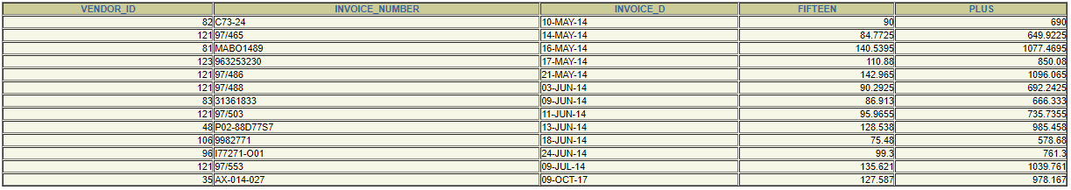

1. (20pts) Write a select statement that return 5 columns from three tables:
   1. Vendor name: vendor_name
   2. Invoice date: invoice_date
   3. Invoice number: invoice_number
   4. Invoice sequence line item: invoice_sequence from the invoice_line_item table
   5. Line item amount: line_item_amt from the invoice_line_item table

Use the following aliases for the tables ‘vd’ for vendors table, ‘inv’ for invoices table, ‘invli’ for invoice_line_item table.

Filter the results to only show those vendors who have the abbreviation “Inc” in their name.

Sort your result set by: vendor name, invoice date, and invoice sequence

“select vd.vendor_name, inv.invoice_date, inv.invoice_number,

invli.invoice_sequence,

invli.line_item_amt

from invoices inv, vendors vd, invoice_line_items invli

where inv.vendor_id = vd.vendor_id and invli.invoice_id = inv.invoice_id and vd.vendor_name like '%Inc%'

order by vd.vendor_name, inv.invoice_date, inv.invoice_number;”

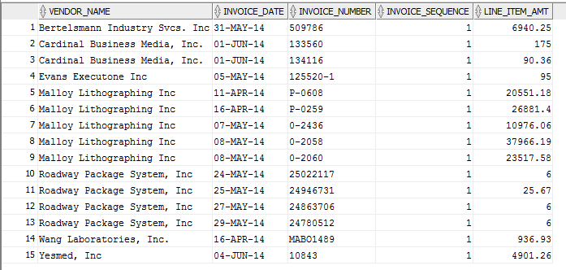

1. (20 pts) Write a select statement that return one row for each vendor_state that contain three columns:
   1. Vendor state: vendor_state
   2. The count of the vendors in each state
   3. The sum of the invoices total for all invoices for the vendors of each state.

Ex.

|  |  |  |
| --- | --- | --- |
| Vendor state | Vendors count | Total sum of invoices |
| MD | 14 | 36820 |
| .. | .. | .. |
| .. | .. | .. |

Filter the result set to include only those rows with a sum less than 5000.

Then, sort the result set in descending order by the count of vendors.

“

select vd.vendor_state, count(*), sum(inv.invoice_total)

from vendors vd, invoices inv

where vd.vendor_id = inv.vendor_id

group by vd.vendor_state

having sum(inv.invoice_total) <= 50000;

“

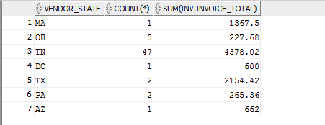

1. (20pts) Write a select statement that return 4 column from invoices table named, vendor id, invoices id, invocie total, invoice category. These columns should contain the following
   1. Vendor id : vendor_id
   2. Invoice id : invoice_id
   3. Invoice total: invoice_total
   4. Invoice category: a case function that categorize the invoice_total into 4 categories as following:
      1. If invoice total is greater than (3*stddev(invoice_total)+avg(invoice_total)) print ‘HIGH’
      2. If invoice total is greater than (avg(invoice_total)) then print ‘ ABOVE AVERAGE’
      3. If invoice total is greater than (avg(invoice_total)/2) then print ‘BELOW AVERAGE’
      4. Else print ‘ low’

Hint :

*stddev is the function for standard deviation in oracle

* each condition in the case function should be in subqueries:

Ex. “>(select 3*stddev(invoice_total)+avg(invoice_total) from invoices)”

“

select vendor_id, invoice_id, invoice_total, case

when invoice_total > (select 3 * stddev(invoice_total) + avg(invoice_total) from invoices) then 'HIGH'

when invoice_total > (select avg(invoice_total) from invoices) then 'ABOVE AVERAGE'

when invoice_total > (select avg(invoice_total)/2 from invoices) then 'BELOW AVERAGE'

else 'LOW'

end as invoice_category

from invoices

where rownum <= 15

group by vendor_id, invoice_id, invoice_total;

“

